A
PROJECT REPORT
on
“Customer Segmentation & Sales Performance Analysis”
SUBMITTED IN PARTIAL FULFILLMENT OF THE REQUIREMENT FOR THE DEGREE OF
B.TECH (Artificial Intelligence & Data Science)
of
Dr. Babasaheb Ambedkar Technological University, Lonere

by

Sahil Narayan Dalavi
Trupti Baburao Chougale

Under the Guidance of
Prof. -Name: Dr.S.S.Sarade



DEPARTMENT OF ARTIFICIAL INTELLIGENCE & DATA SCIENCE

Shri. Balasaheb Mane Shikshan Prasarak Mandal, Ambap’s
ASHOKRAO MANE GROUP OF INSTITUTIONS
FACULTY OF ENGINEERING
Vathar Tarf Vadgaon, Dist. Kolhapur

ACADEMIC YEAR 2025-2026

CERTIFICATE

This is to certify that the project entitled, “Customer Segmentation & Sales Performance Analysis” submitted by Sahil Dalavi & Trupti Chougale is record of bonafide work carried out by them, under my guidance, in partial fulfillment of the requirement for the award of Degree of Bachelors of Technology (Artificial Intelligence & Data Science) of Dr. Babasaheb Ambedkar Technological University, Lonere for the academic year 2025-2026.

Date: / /2026
Place: Ashokrao Mane Group of Institutions, Vathar Tarf Vadgaon.

(GUIDE) (HOD) (Director)
(Prof: S.S.Sarade) (Dr. S.S.Sarade) (Dr. S.R.Chogule)

Declaration

We hereby declare that the work which is being presented in the project entitled “Customer Segmentation & Sales Performance Analysis” submitted in the DEPARTMENT OF ARTIFICIAL INTELLIGENCE & DATA SCIENCE is an authentic record of our own work carried under the supervision of Prof.
Dr.S.S.Sarade

This study has not been submitted to any other institution or university for the award of any other degree.

Date: / /2026
Place: Ashokrao Mane Group of Institutions, Vathar Tarf Vadgaon.

Sahil Narayan Dalavi,
Trupti Baburao Chougale

ACKNOWLEDGEMENT

It gives us immense pleasure to express our sincere hearty gratitude for the constant help, encouragement and suggestions given to us for present our dissertation work entitled “Customer Segmentation & Sales Performance Analysis” under the guidance of Prof. Dr.S.S.Sarade.
His/hers encouraging guidance enabled us to complete this task.
We are thankful to Dr. S. R. Chougule, Director, AMGOI for continuous motivation towards our project. We are also thankful to Prof. P. B. Ghewari, Vice Principal, AMGOI for continuously encouraging us. We would like to thank Dr. S. S. Sarade (HOD) who helped us to build this project. We extend our thanks to staff members of Artificial Intelligence & Data Science and all our friends who have extended their cooperation for the completion of this task
Finally, we express our gratitude to Almighty GOD and our PARENTS who have inspired & supported us to complete this work, without their support we could not have completed this task.

Date: / / 2026

Introduction
Customer Segmentation & Sales Performance Analysis is a Business Intelligence and Data Analytics project developed using Power BI to analyze customer behavior, sales trends, and revenue performance. In today’s competitive business environment, organizations generate a large amount of customer and sales data every day. Analyzing this data manually is difficult, time-consuming, and may lead to errors in decision-making.
This project provides an interactive and visual solution for understanding customer purchasing patterns and overall business performance. The Analysis converts raw sales data into meaningful insights using charts, graphs, KPI cards, and filters. It helps businesses identify profitable customer groups, analyze category-wise sales, and monitor revenue growth effectively.
The system includes important analytical features such as Active Customers, Total Revenue, Average Order Value, Revenue by Category, Sales by Age Group, and Subscription Status Analysis. Interactive filters like Gender, Category, Shipping Type, and Subscription Status allow users to perform customized analysis according to business requirements.
The main purpose of this project is to help businesses make better data-driven decisions by providing clear and accurate visualization of customer and sales information. This Analysis improves business analysis, customer understanding, and strategic planning through modern Business Intelligence techniques.

Background

With the rapid growth of digital business and e-commerce platforms, organizations generate huge amounts of customer and sales data daily. Businesses need efficient systems to analyze this data and understand customer behavior, purchasing patterns, and sales performance. Traditional methods of maintaining sales records and customer details using spreadsheets or manual reports are time-consuming, less accurate, and difficult to manage for large datasets.

Customer segmentation and sales analysis have become essential for improving marketing strategies, customer satisfaction, and business growth. Companies use customer analytics to identify profitable customer groups, understand customer preferences, and improve decision-making processes. However, without proper visualization tools, analyzing raw data becomes complex and inefficient.

Business Intelligence tools such as Power BI provide advanced visualization and reporting features that help organizations transform raw data into meaningful insights. Interactive Analysiss allow users to monitor business performance in real time through charts, graphs, KPI cards, and filters.

The Customer Segmentation & Sales Performance Analysis project was developed to provide a centralized and interactive platform for analyzing customer data and sales trends. The Analysis helps businesses understand revenue generation, category-wise sales performance, customer age-group analysis, and subscription behavior efficiently. By using data visualization techniques and Business Intelligence concepts, the project improves decision-making and supports better business strategies.

Theoretical Description

The Customer Segmentation & Sales Performance Analysis works based on the principles of Business Intelligence (BI), Data Analytics, Data Visualization, and Customer Segmentation techniques. The main purpose of this system is to transform raw customer and sales data into meaningful visual insights that support business decision-making.

The project uses Power BI as the primary Business Intelligence tool for data processing, visualization, and Analysis creation. The Analysis analyzes customer behavior, sales performance, and revenue trends through interactive charts, graphs, KPI cards, and filters.

a) Customer Segmentation Module
- Groups customers based on Age Group, Gender, and Subscription Status.
- Helps businesses identify target customer categories.
- Improves understanding of customer purchasing behavior.
b) Sales Analysis Module
- Analyzes category-wise sales and revenue performance.
- Identifies high-performing products and profitable categories.
- Tracks sales trends and customer demand.
c) Revenue Analysis Module
- Calculates Total Revenue and Average Order Value.
- Provides graphical representation of revenue generation.
- Helps businesses monitor financial performance.
d) Data Visualization Module
- Displays information using charts, KPI cards, graphs, and slicers.
- Makes complex data easier to understand and analyze.
- Supports interactive business reporting.
e) Interactive Filtering Module
- Allows filtering based on Category, Gender, Shipping Type, and Subscription Status.
- Provides customized analysis according to user requirements.
f) Technology Used
- Frontend / Visualization Tool: Power BI Desktop
- Dataset Format: Excel / CSV Files
- Data Processing: Power Query
- Calculations & KPIs: DAX (Data Analysis Expressions)
- Cloud Support: Power BI Service (Optional)

The project demonstrates how Business Intelligence and Data Analytics techniques can improve customer understanding, sales monitoring, and strategic business planning through interactive Analysiss and visual reporting.

Working Principle

The working principle of the Customer Segmentation & Sales Performance Analysis is based on collecting customer and sales data, processing it using Power BI, and generating interactive visual reports for business analysis. The system transforms raw datasets into meaningful insights through data cleaning, analysis, and visualization techniques.

6.1 Block Diagram: -

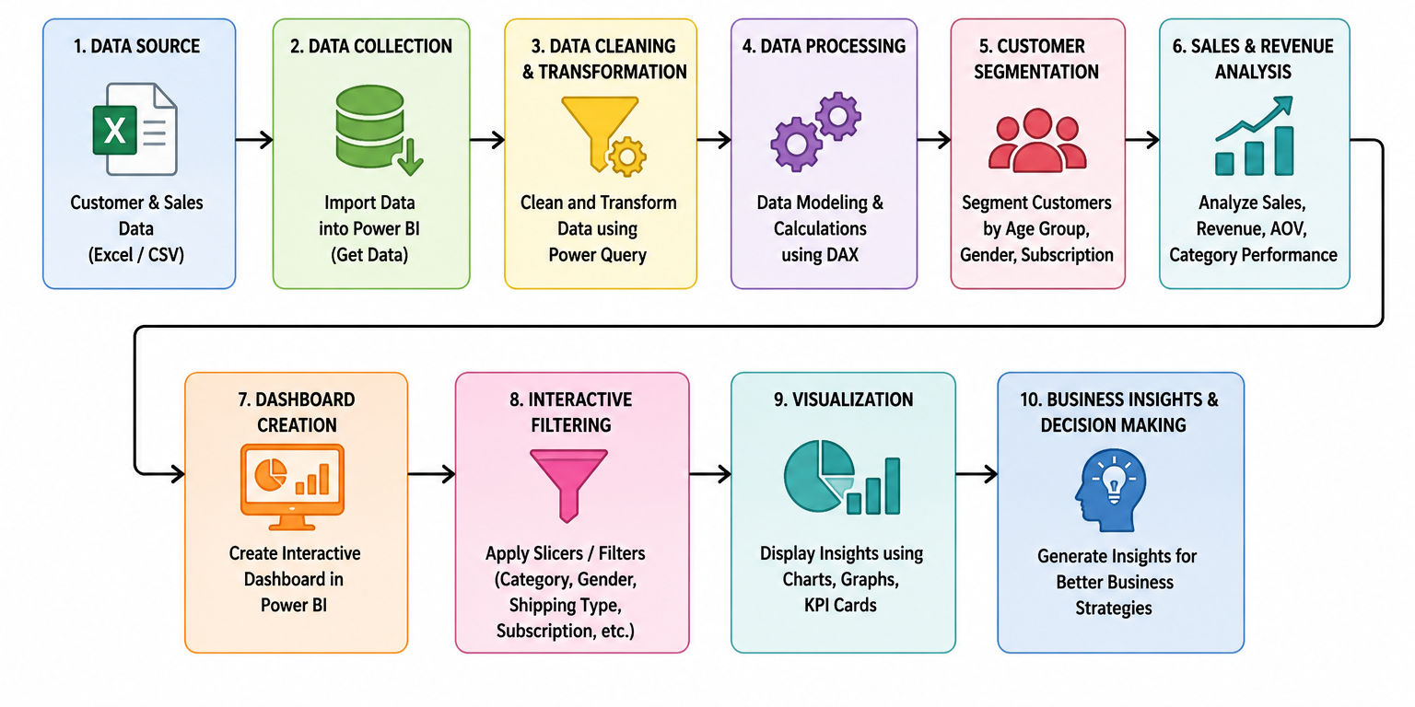

Advantages

- Easy-to-use and interactive Analysis interface.
- Provides quick analysis of customer behavior and sales trends.
- Helps identify profitable customer groups and product categories.
- Converts raw data into meaningful visual insights.
- Supports data-driven business decision-making.
- Interactive filters improve customized analysis.
- Reduces manual effort in sales reporting and analysis.
- Improves understanding of revenue and customer performance.
- Real-time visualization makes business monitoring easier.
- Power BI Analysis is scalable and user-friendly.

Disadvantages

- Depends on accurate and clean datasets for proper analysis.
- Large datasets may reduce Analysis performance.
- Requires basic knowledge of Power BI and data analytics.
- Limited predictive analysis without advanced AI/ML integration.
- Analysis functionality depends on system performance and memory.
- Data security risks may arise if proper access control is not maintained.
- Real-time data integration may require additional cloud services.
- Some advanced Power BI features require internet connectivity and premium services.

Future Scope

With advancements in Business Intelligence and Data Analytics technologies, the Customer Segmentation & Sales Performance Analysis can be enhanced further with advanced features and real-time capabilities.

Future Enhancements
- Integration with real-time databases and cloud platforms.
- AI and Machine Learning models for sales prediction and customer behavior forecasting.
- Mobile application support for Analysis access anywhere.
- Real-time sales monitoring using live data streaming.
- Advanced customer recommendation systems based on purchasing patterns.
- Integration with e-commerce platforms for automatic data updates.
- Enhanced security features and role-based access control.
- Automated report generation and email notifications.
- Multi-branch or multi-store sales analysis support.
- Cloud deployment using Microsoft Azure or Power BI Service for global accessibility.

These future improvements can make the system more intelligent, scalable, efficient, and suitable for modern business environments.

Conclusion

The Customer Segmentation & Sales Performance Analysis is an effective Business Intelligence solution developed to analyze customer behavior and sales performance using Power BI. The project transforms raw customer and sales data into meaningful visual insights through charts, graphs, KPI cards, and interactive filters.

The Analysis helps businesses identify profitable customer groups, analyze category-wise sales performance, monitor revenue trends, and understand customer purchasing behavior efficiently. It reduces manual analysis efforts and improves decision-making through data visualization techniques.

Features such as customer segmentation, sales analysis, revenue monitoring, and interactive filtering make the system user-friendly, efficient, and beneficial for business growth.

Overall, this project demonstrates the importance of Data Analytics and Business Intelligence in modern business environments. With future enhancements like AI integration, real-time analytics, and cloud deployment, the system can become more intelligent, scalable, and powerful for advanced business analysis.

